 **NATIONAL UNIVERSITY**

**OF MODEREN LANGUAGES**

**PROJECT REPORT ON**

**“UNIVERSITY ADMISSION APP”**

**SUBJECT:**

PROGRAMMING FUMDAMENTALS

**SUBMITTED TO:**

MS. MARYAM IMTIAZ

**SUBMITTED BY:**

JANEES ASGHAR(NUML-F23-31170)

MAHNOOR KHALID(NUML-F23-36140)

SADIA(NUML-F23-33730)

SYEDA ALISHAH(NUML-F23-24297)

MUHAMMAD SANI(NUML-F23-30730)

**INDEX:**

**Contents:**

* DECLARATION:
* ACKNOWLEDGMENT
* PROBLEM ANALYZIATION
* PROBLEM REQUIREMENT
* DESIGN(Algorithm)
* IMPLEMENTATION
* FEATURES(Output) (testing and verifying)
* CONCLUSION
* SUGGESTION

DECLARATION:

We, the architects of the university admission program, are devoted to crafting an innovative system that revolutionizes admission processes, under the supervision of Miss Maryam Imtiaz Malik Our mission revolves around creating a comprehensive, technology-driven program that merges ethical standards seamlessly to ensure a fair, efficient, and accessible admission experience. Our primary goal is to foster exclusivity and transparency, designing a user-centric platform that simplifies applications while guaranteeing equal opportunities for all, regardless of background. Upholding stringent ethical standards, our program prioritizes data security, confidentiality, and procedural integrity at every stage. Our commitment lies in integrating robust safeguards to protect applicants' privacy, maintaining the highest ethical benchmarks throughout the admission process."

ACKNOWLEDGMENT:

We express our sincere gratitude to the dedicated team members whose tireless efforts and unwavering commitment have been instrumental in conceptualizing and developing the university admission program. Additionally, we extend our heartfelt appreciation to the academic advisors, administrators, and experts whose invaluable insights and guidance have significantly contributed to shaping this innovative initiative. We also acknowledge the support and cooperation of the educational institutions and prospective students whose collaboration and feedback have been integral in refining and enhancing the program. Their collective contribution has been indispensable in shaping this trans formative endeavor aimed at redefining the landscape of higher education admissions."

**PROBLEM ANALYZATION:**

The current university admission process faces several challenges that impact its efficiency and accessibility. One of the primary issues is the complexity and lack of transparency in the application procedure, leading to confusion among prospective students. The absence of a unified platform for submitting applications and tracking their progress creates inconvenience and inefficiencies for both applicants and admission staff.

Students face difficulties in collecting information about various universities, including eligibility criteria, merit requirements, and application procedures, after completing their intermediate education. Students find it challenging to gather comprehensive details about multiple universities in one place. The process of individually researching each university's admission requirements is time-consuming. Students may lack clarity on eligibility criteria and merit requirements for different universities. Needed to develop a centralized system, such as a mobile application, that provides information about various universities. The system should allow students to explore eligibility criteria, merit thresholds, and application procedures for different universities within a single platform. Design an intuitive interface to make it easy for students to navigate and access information.

**PROBLEM REQUIREMENTS:**

* Need to Develop a user-friendly interface for easy navigation and understanding
* Enable the system to calculate merit for each user based on specified criteria.
* Need to Provide detailed eligibility criteria for universities, including academic and other requirements.
* Needed to Establish the system as an information hub for comprehensive university details and admission processes.
* Needed to Empower users with extensive knowledge about universities for informed decision-making.
* Implement mechanisms for regular updates and verification of university information.
* Establish collaborations with universities for real-time data integration.
* Ensure robust security measures to safeguard user data and maintain privacy in the admission process.

**DESIGN**

**(Algorithm):**

1. **Start**
2. **University application app**
3. **OUR UNIVERSITIES LIST IS:**

BAHRIA UNIVERSITY

COMSATS UNIVERSITY

FOUNDATION UNIVERSITY

GIFT UNUVERSITY GUJRAWALA

RIPHA INTERNATIONAL UNIVERSITY

AIR UNIVERSITIES

FAST UNIVERSITY

ALLAMA IQBAL UNIVERSITY

NATIONAL DEFENCE UNIVERSITY

NUST UNIVERSITY

1. **Fill the foam**
2. **Name university you want to apply in**
3. **Calculate merit**

**merit** =30% matric marks+40%intermediate marks+30 %NTS marks

if **NUST** (merit =30% matric marks+40%intermediate marks+10 %NTS marks+20%NAT marks)

1. **Check Eligibility criteria using merit**

**If (merit>= eligibility criteria)**

Show fee voucher

**Else**

Apply for another university

1. **Thank you for using APP**
2. **End**

**(Flowchart):**

**University application app**

**Displaying Universities list**

**Fill the form**

**Enter the university you want to apply in**

**merit** =30% matric marks+40%intermediate marks+30 %NTS marks

if **NUST** (merit =30% matric marks+40%intermediate marks+10 %NTS marks+20%NAT marks)

**Display merit**

**Display eligibility criteria**

**If (merit >=eligibility criteria)**

**FALSE** **TRUE**

**Display test Fee Voucher**

**You cannot apply for this university**

**Thank you for using this app**

**IMPLEMENTATION (CODE):**

include<iostream>

#include<string.h>

using namespace std;

* **Function for form:**

void foam()

{

int day, month, year;

char dash;

string gender, matric, intermediate, password;

char name[15];

char fn[15];

char arr[50];

char sch[25];

char hal[25];

char e[50];

char f[25];

char n[15];

char m[15];

cout << "\n^^^^^^^^^^^^^^^^^^^^^^^^^^^^^^^^UNIVERSITY APPLICATION FORM^^^^^^^^^^^^^^^^^^^^^^^^^^^^ ";

cout << "\n ";

cout << " \n--------------------------- ";

cout << "\nPERSONAL INFORMATION:";

cout << " \n--------------------------- ";

cout << "\nenter your email:";

cin.ignore();

cin.get(e, 50);

cout << "\nenter your password:";

cin >> password;

cout << "\nEnter your Full Name: ";

cin.ignore();

cin.get(name, 15);

cout << "\nEnter yours father Full Name: ";

cin.ignore();

cin.get(fn, 25);

cout << "\nEnter your Date of Bith: ";//Enter your date of birth (dd-mm-yyyy)

cin >> day >> dash >> month >> dash >> year;

cout << "\nenter your CNIC number :";

cin.ignore();

cin.get(n, 15);

cout << "\nenter yours father CNIC number :";

cin.ignore();

cin.get(m, 15);

cout << "\nEnter your Gender: ";

cin >> gender;

cout << "\nEnter your Adress: ";

cin.ignore();

cin.get(arr, 50);

cout << "\n------------------------ ";

cout << "\nACADEMIC BACKGROUND:";

cout << "\n------------------------ ";

cout << "\nenter the field you want to apply in : ";

cin.ignore();

cin.get(f, 25);

cout << "\nEnter Your School Name :";

cin.ignore();

cin.get(sch, 25);

cout << "\nEnter your group name of matric :";//e.g : biology;computer;humanity

cin >> matric;

cout << "\nEnter Your college Name :";

cin.ignore();

cin.get(hal, 25);

cout << "\nEnter your group name of intermediate :";//e.g : fsc;ics;FA

cin >> intermediate;

cout << "\n ";

cout << "\nthank you for filling the form";

cout << "\n---------------------------------------------------------------------";

}

* **Function describing eligibility criteria:**

void merit(string name)

{

if (name == "bahria" || name == "foundation" || name == "gift" || name == "allama iqbal" || name == "national defence university")

{

cout << "your merit should must be 55 percent elase you cannot apply for this university";

}

else if (name == "nust" || name == "fast" || name == "air" || name == "comsats")

{

cout << "your merit should must be 70 percent elase you cannot apply for this university";

}

else if (name == "ripha")

{

cout << "your merit should must be 40 percent elase you cannot apply for this university";

}

}

* **Function for displaying fee voucher:**

void feevoucher(string name)

{

if (name == "bahria" || name == "foundation" || name == "gift" || name == "allama iqbal" || name == "national defence university")

{

cout << "\n---------------------------------------------------------------------";

cout << "\nyour fee voucher for this university is";

cout << "\nyour entry test fees is :1200";

cout << "\nother credential : 800";

cout << "\nyour total fee is : 2000";

cout << "\n---------------------------------------------------------------------";

}

else if (name == "nust" || name == "fast" || name == "air" || name == "comsats")

{

cout << "\n---------------------------------------------------------------------";

cout << "\nyour fee voucher for this university is";

cout << "\nyour entry test fees is :1800";

cout << "\nother credential : 1200";

cout << "\nyour total fee is : 3000";

cout << "\n---------------------------------------------------------------------";

}

else if (name == "ripha")

{

cout << "\n---------------------------------------------------------------------";

cout << "\nyour fee voucher for this university is";

cout << "\nyour entry test fees is :1500";

cout << "\nother credential : 1000";

cout << "\nyour total fee is : 2500";

cout << "\nyours admit card for test of each university will be send to you through E-mail";

cout << "\n---------------------------------------------------------------------";

}

}

* **MAIN PROGRAM**

int main()

{

char c;

string name;

cout << "\n**********************welcome to university admission APP";

**\\ UNIVERSITIES WE DEAL WITH**

cout << "\nour app deal with fallowing 10 universities";

cout << "BAHRIA UNIVERSITY \n COMSATS UNIVERSITY\n FOUNDATION UNIVERSITY \n GIFT UNUVERSITY GUJRAWALA \n RIPHA INTERNATIONAL UNIVERSITY \n AIR UNIVERSITIES \n FAST UNIVERSITY \n ALLAMA IQBAL UNIVERSITY\n NATIONAL DEFENCE UNIVERSITY \n NUST UNIVERSITY ";

cout << "\nyou can apply only in this 10 universities";

**\\ CALLING FOAM FUNCTION**

foam();

do

{

int matric, fsc, nts;

**\\TAKING** **NAME OF UNIVERSITY FROM USER**

cout << "\nenter the name of university you want to apply in" << endl;

cin >> name;

merit(name);

cout << "\nenter the number of matric:";

cin >> matric;

cout << "\nenter the number of fsc:";

cin >> fsc;

cout << "\nenter the number of NTS:";

cin >> nts;

**\\CALCULATING** **MERIT**

int merit = matric * 30 / 1000 + fsc * 40 / 1000 + nts * 30 / 100;

if (name == "nust")

{

int NAT;

cout << "enter the NAT marks";

cin >> NAT;

int merit = matric * 30 / 1000 + fsc * 40 / 1000 + nts * 10 / 100 + NAT * 20 / 100;

}

cout << "\nyour merit is" << merit << "%";

**\\APPLYING** **CONDITION THAT LESS THAN 40% CANNOT APPLY IN ANY UNIVERSITY**

if (merit < 40)

{

cout << "\nsorry your merit is too low you cannot apply in any of this university";

break;

}

**\\CHEAKING** **ELIGIBILITY CRITERIA AND DISPLAYING FEE VOUCHER:**

if (name == "bahria" || name == "foundation" || name == "gift" || name == "allama iqbal" || name == "national defence university")

{

if (merit < 55)

{

cout << "\nsorry your merit is low for this university you cannot apply in this university ";

}

else

{

feevoucher(name);

}

}

else if (name == "nust" || name == "fast" || name == "air" || name == "comsats")

{

if (merit < 70)

{

cout << "\nsorry your merit is low for this university you cannot apply in this university ";

}

else

{

feevoucher(name);

}

}

else if (name == "ripha")

{

if (merit < 40)

{

cout << "\nsorry your merit is low for this university you cannot apply in this university and you also cannot apply in any else university ";

}

else

{

feevoucher(name);

}

break;

}

else

{

cout << " ";

}

**\\CONDITION** **TO ESCAPE FROM LOOP**

cout << "\nif you dont want to apply for any else university enter n";

cin >> c;

} while (c != 'n');

**\\ENDING**

cout << "\nThank you for using our app. I hope you enjoyed it!";

return 0;

}

FEATURES(Output) (testing and verifying)

**FIRSTLY, PROGRAM STARTS DISPLAYING ALL UNIVERSITIES NAME:**

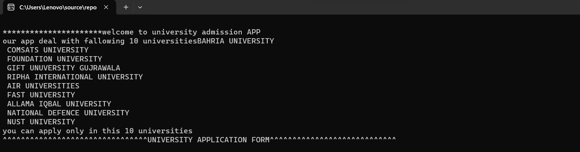

**Function of foam taking all information from user:**

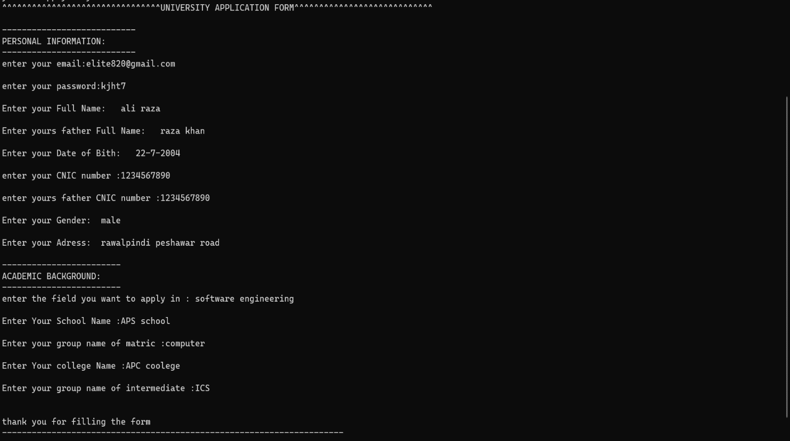

* **Taking university name from user in which he/she want to apply**
* **Displaying eligibility criteria**
* **Calculating merit**
* **And displaying fee voucher**

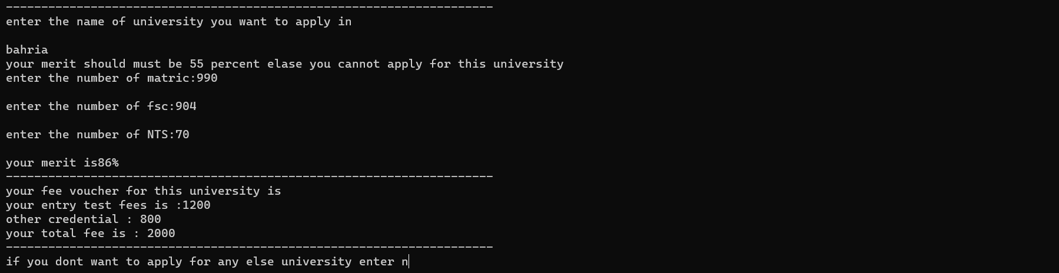

**What happen if eligibility criteria are low to apply for a university:**

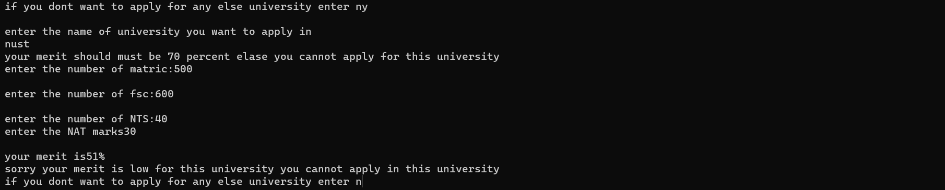

**When your merit is too low to apply in any university:**

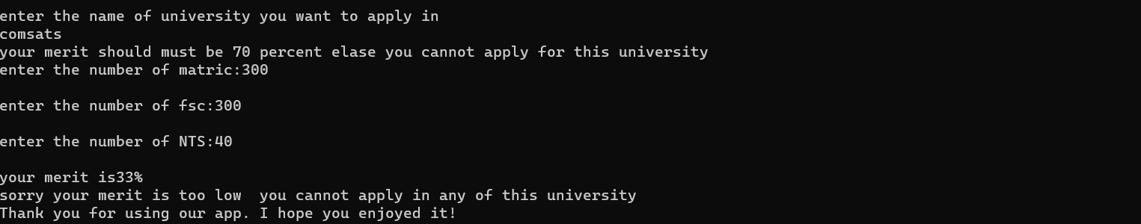

CONCLUSION:

* **Successful integration** of cutting-edge technology into the admission process, enhancing efficiency and accuracy.
* **Improved accessibility** for diverse applicant demographics, ensuring inclusive and equal opportunities for all.
* **Establishment of stringent ethical standards** safeguarding data security, confidentiality, and procedural integrity throughout the admission program.
* **Positive impact on the user experience,** simplifying the application process while maintaining transparency and fairness.
* **Collaboration with educational institutions** and stakeholders to gather feedback and implement necessary enhancements.
* **The trans formative nature of the program** marks a significant advancement in reshaping higher education admissions, emphasizing

fairness, transparency, and technological innovation.

SUGGESTIONS:

….………………………………………………………………………………………………………………………………………………………………………………………………………………………………………………………………………………………………………………………………………………………………………………………………………………………………………………………………………